STATE OF LOUISIANA
PARISH OF UNION

******************************************************************************
DONATION DEED

BE IT KNOWN before me, the undersigned Notary Public in and for the aforesaid parish and state, and in the presence of the undersigned competent witnesses, personally came and appeared:

______________________________________________, SS # XXX-XX-__________ and ___________________________________________,SS# XXX-XX-__________ together and unseparated and undivorced, both major residents and domiciliaries of Union Parish, Louisiana, whose present mailing address is _______________________________ ________________________________________________________________________

hereinafter referred to as "DONOR", AND

______________________________________________, SS # XXX-XX-__________ and ___________________________________________,SS# XXX-XX-__________ together and unseparated and undivorced, both major residents and domiciliaries of Union Parish, Louisiana, whose present mailing address is _______________________________ ________________________________________________________________________

hereinafter referred to as "DONEE", who did covenant and agree as follows:

§1. DONATION. Subject to the terms, conditions, limitation and reservations hereinafter stated, and for and in consideration of the love and affection which DONOR bears for DONEE, DONOR has given, donated and delivered, and by this formal act of donation irrevocably give and donates inter vivos and delivers unto DONEE, as the separate property of DONEE, the following property together with the improvements and appurtenances thereunto belonging, but subject to any duly recorded rights of way or servitudes, situated in the Parish of Union, State of Louisiana, to-wit:

§2 HABENDUM CLAUSE. TO HAVE AND TO HOLD the PROPERTY unto DONEE, DONEE heirs, successors and assigns forever.

§3 MINERAL RESERVATION. DONOR reserves all of the oil, gas or other minerals in and under which may be produced from the property.

§4 TAXES. DONOR declares that all ad valorem taxes for all prior years due on the property have been paid. DONEE shall be responsible for payment of all the taxes for the current and following years.
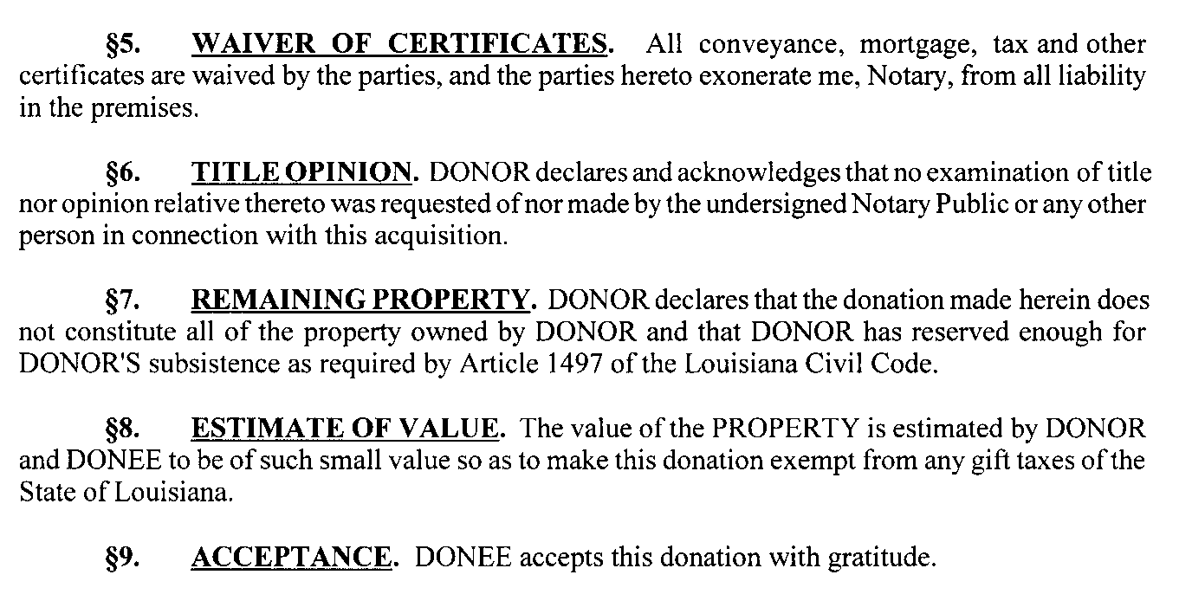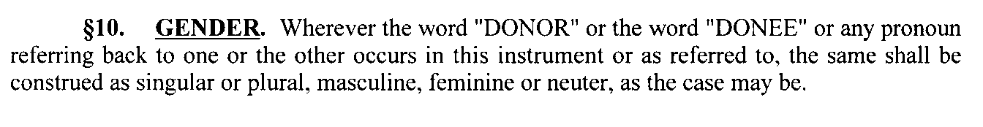
§11 ACKNOWLEDGMENT. DONEE acknowledges this to be part of her inheritance.
THUS DONE AND PASSED on the _________ day of __________, 20____, at Farmerville, Union Parish, Louisiana, the donation deed having affixed his signatures hereto and on the day and date first above written together with me, Notary, and the undersigned witnesses, after due reading of the whole.

WITNESSES:
________________________________ __________________________________________
DONOR

________________________________ __________________________________________
DONOR

______________________________________
NOTARY PUBLIC

THUS DONE AND PASSED on the _______day of _______________, 20_____, at Farmerville, Union Parish, Louisiana, the donation deed having affixed his signatures hereto and on the day and date first above written together with me, Notary, and the undersigned witnesses, after due reading of the whole.

WITNESSES:
________________________________ ____________________________________ DONEE

________________________________ ___________________________________
DONEE

______________________________________
NOTARY PUBLIC

